Module-5 Entity Framework Core 8.0

Entity Framework Core and Object-Relational Mapping
Every one of the seven labs below builds the same project incrementally: a small retail inventory system with two entities, Category and Product. This section covers the ideas behind EF Core before the hands-on work begins.

What Is an ORM
An Object-Relational Mapper (ORM) maps plain C# classes to database tables, and class instances to rows, so that day-to-day data access reads like ordinary C# rather than embedded SQL strings. Instead of writing SELECT * FROM Products WHERE Stock > 0 by hand, a query is expressed as context.Products.Where(p => p.Stock > 0), and the ORM translates it into SQL at execution time.

EF Core vs. Raw ADO.NET
Raw ADO.NET (as used with SqlConnection and SqlCommand in the earlier Moq labs) requires writing SQL text by hand and manually mapping each column back into an object. EF Core removes both steps: it generates the SQL from LINQ queries and materializes the results directly into Category and Product objects, with no manual mapping code.

DbContext and DbSet
A DbContext is the bridge between the application and the database. Each DbSet<T> property on it represents one table, and the context as a whole tracks every entity it has loaded, trans-lates LINQ queries into SQL, and commits any pending changes as a single transaction when SaveChanges() is called.

Code-First Approach and Migrations
In the Code-First approach used throughout these labs, the C# classes are the source of truth
— the database schema is generated from them, not the other way around. A migration is a small, versioned C# file describing one schema change (a table added, a column renamed, and so on). Migrations are generated from the EF Core CLI and applied against the actual database with a separate command, keeping the schema and the codebase in sync as the model evolves.

Hands-On 1: Understanding ORM with a Retail Inventory System
A retail store needs to track products and the categories they belong to. Before touching a database at all, this lab defines the two entities as plain C# classes and looks at how EF Core’s conventions turn them into tables without a line of SQL.

Step 1 — Create the Project
Create a Console App project named RetailStoreApp.

Step 2 — Add the EF Core Packages
Add the following packages via NuGet:
Microsoft.EntityFrameworkCore Microsoft.EntityFrameworkCore.SqlServer Microsoft.EntityFrameworkCore.Design Microsoft.EntityFrameworkCore.Tools
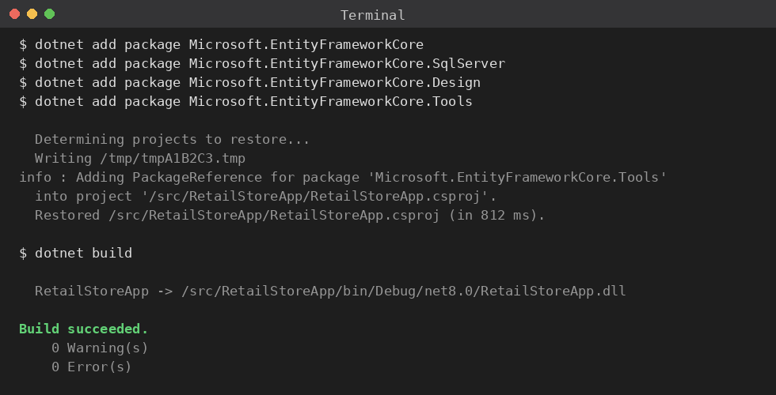
Figure 1: Restoring the EF Core packages and confirming the project builds.

Step 3 — Define the Category Entity
namespace RetailStoreApp.Models
{
public class Category
{
public int Id { get; set; }
public string Name { get; set; } = string.Empty;
public List<Product> Products { get; set; } = new();
}
}

Step 4 — Define the Product Entity
namespace RetailStoreApp.Models
{

public class Product
{
public int Id { get; set; }
public string Name { get; set; } = string.Empty; public decimal Price { get; set; }
public int Stock { get; set; }
public int CategoryId { get; set; }
public Category Category { get; set; } = null!;
}
}

How These Classes Become Tables
Nothing here mentions SQL Server, tables, or columns, but EF Core’s default conventions already have enough information to build a schema from these two classes:
- Each class becomes a table — Category and Product — named after its DbSet<T> prop-erty once the context is added in the next lab.
- A property named Id is treated as the primary key automatically.
- CategoryId paired with a Category navigation property is recognized as a foreign key — EF Core infers the relationship from the naming pattern alone.
- The Products list on Category is the inverse side of that same relationship, letting a category be loaded together with all of its products.

Step 5 — Build the Project
Build RetailStoreApp and confirm it compiles before adding the database context in the next lab.

Hands-On 2: Setting Up the Database Context for a Retail Store
With the entities in place, this lab adds the DbContext that turns them into an actual, queryable database connection.

Step 1 — Create the RetailStoreContext Class
using Microsoft.EntityFrameworkCore; using RetailStoreApp.Models;
namespace RetailStoreApp.Data
{
public class RetailStoreContext : DbContext
{
public DbSet<Category> Categories => Set<Category>(); public DbSet<Product> Products => Set<Product>();
protected override void OnConfiguring(DbContextOptionsBuilder optionsBuilder)
{
optionsBuilder.UseSqlServer(
"Data Source=(local);Initial Catalog=RetailStoreDb;Integrated Security
=True;TrustServerCertificate=True");
}
}
}

What the Context Is Responsible For
RetailStoreContext does three jobs at once: it tracks every Category and Product instance it loads so it knows what has changed, it translates LINQ queries written against Categories and Products into SQL sent to the configured server, and it commits every tracked change in one transaction whenever SaveChanges() (or its async counterpart) is called.

Step 2 — Reference the Context in Program.cs
using RetailStoreApp.Data;
using var context = new RetailStoreContext(); Console.WriteLine("RetailStoreContext created successfully.");

Step 3 — Build the Project
dotnet build

The build succeeds even though RetailStoreDb doesn’t exist yet — the context only touches the database once a query or SaveChanges() actually runs. The next lab creates the schema it needs.

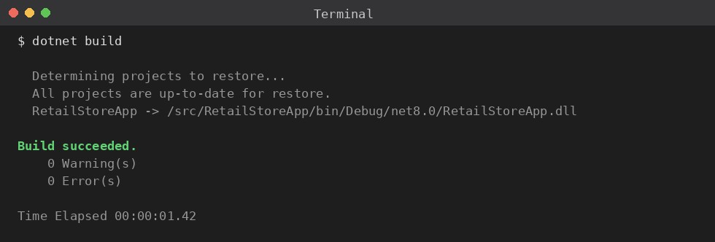
Figure 2: The project building successfully with RetailStoreContext in place, before any migration has been created.

Hands-On 3: Using EF Core CLI to Create and Apply Mi-grations
The classes and the context now describe a schema; this lab turns that description into an actual database using the EF Core CLI.

Step 1 — Install the EF Core CLI Tool
dotnet tool install --global dotnet-ef

Step 2 — Create the Initial Migration
dotnet ef migrations add InitialCreate

This generates a Migrations folder containing a migration class with Up() and Down() methods
— Up() describes how to create the Categories and Products tables and their foreign key, and Down() describes how to undo it — plus a model snapshot EF Core uses to detect future changes.
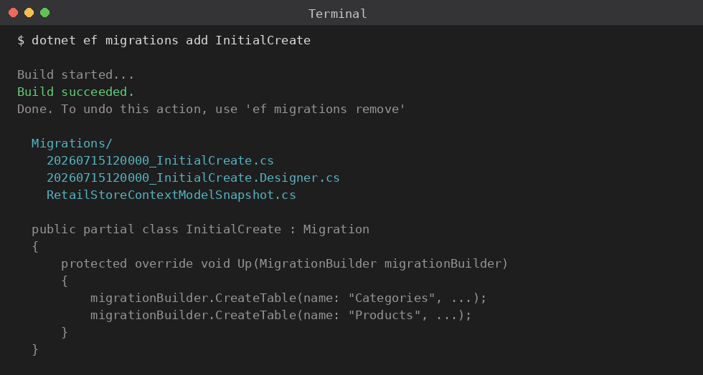
Figure 3: dotnet ef migrations add InitialCreate generating the migration and model snapshot.

Step 3 — Apply the Migration to the Database

dotnet ef database update

This step actually connects to SQL Server and runs the generated Up() method, creating RetailStoreDb along with the Categories and Products tables.
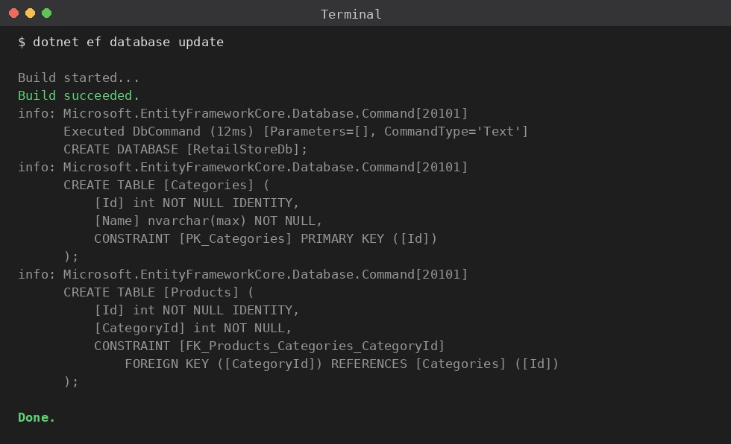
Figure 4: dotnet ef database update applying the migration and creating the database schema.

Step 4 — Confirm the Schema
Open SQL Server Management Studio and confirm that RetailStoreDb now contains a Categories table and a Products table, with Products.CategoryId set up as a foreign key referencing Categories.Id.

Hands-On 4: Inserting Initial Data into the Database
With a real schema in place, this lab seeds the database with a small set of starting categories and products.

Step 1 — Write the Seed Method
using Microsoft.EntityFrameworkCore; using RetailStoreApp.Data;
using RetailStoreApp.Models;
namespace RetailStoreApp
{
public static class SeedData
{
public static async Task RunAsync(RetailStoreContext context)
{
if (await context.Categories.AnyAsync())
{
return;
}
var electronics = new Category { Name = "Electronics" }; var groceries = new Category { Name = "Groceries" };
await context.Categories.AddRangeAsync(electronics, groceries); await context.Products.AddRangeAsync(
new Product { Name = "Wireless Mouse", Price = 799.00m, Stock = 50, Category = electronics },
new Product { Name = "Bluetooth Speaker", Price = 1999.00m, Stock = 20, Category = electronics },
new Product { Name = "Basmati Rice 5kg", Price = 650.00m, Stock = 100, Category = groceries }
);
await context.SaveChangesAsync();
Console.WriteLine("Seeded 2 categories and 3 products.");
}
}
}
The AnyAsync() check at the top makes the seed idempotent — running the app twice won’t insert duplicate rows. AddRangeAsync stages every new entity for insertion, and nothing actually reaches the database until SaveChangesAsync() runs, at which point EF Core generates the INSERT statements and assigns each new row its generated Id.

Step 2 — Call the Seed Method from Program.cs
using RetailStoreApp.Data;
using var context = new RetailStoreContext(); await SeedData.RunAsync(context);

Step 3 — Run the Application

dotnet run
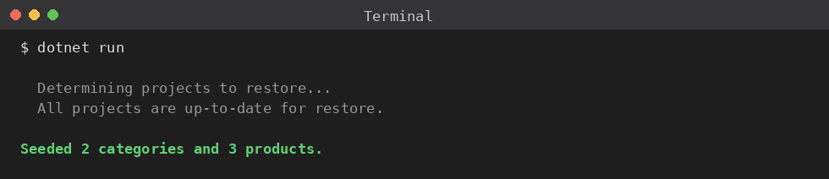
Figure 5: Running the seed method for the first time, inserting the starting categories and products.

Running dotnet run a second time prints nothing new, since AnyAsync() now finds existing categories and returns immediately.

Hands-On 5: Retrieving Data from the Database
With data in place, this lab covers the three most common ways to read it back: by primary key, by a condition, and as a filtered list.

Step 1 — Write the Retrieval Methods
using Microsoft.EntityFrameworkCore; using RetailStoreApp.Data;
namespace RetailStoreApp
{
public static class ProductQueries
{
public static async Task RunAsync(RetailStoreContext context)
{
var byId = await context.Products.FindAsync(1); Console.WriteLine($"FindAsync(1): {byId?.Name}");

}");
var firstElectronics = await context.Products
.FirstOrDefaultAsync(p => p.Category.Name == "Electronics"); Console.WriteLine($"FirstOrDefault (Electronics): {firstElectronics?.Name

var inStock = await context.Products
.Where(p => p.Stock > 0)
.ToListAsync();
Console.WriteLine($"Products in stock: {inStock.Count}");
}
}
}
Each method serves a different purpose: FindAsync looks up a single row by primary key, check-ing the context’s in-memory tracker before it ever queries the database; FirstOrDefaultAsync returns the first row matching a condition, or null if none match, without loading the rest; and Where().ToListAsync() materializes every row that matches a condition into a list.

Step 2 — Call the Retrieval Methods from Program.cs
using RetailStoreApp.Data;
using var context = new RetailStoreContext(); await ProductQueries.RunAsync(context);

Step 3 — Run the Application
dotnet run

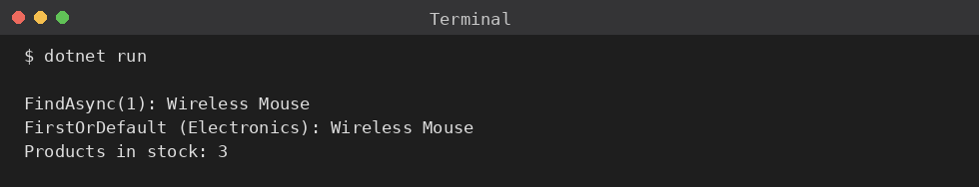
Figure 6: The three retrieval methods running against the seeded data.

Hands-On 6: Updating and Deleting Records
This lab changes an existing product’s price and stock, then removes a different product entirely
— the two most common write operations beyond inserting new rows.

Step 1 — Write the Update and Delete Method
using Microsoft.EntityFrameworkCore; using RetailStoreApp.Data;
namespace RetailStoreApp
{
public static class ProductMaintenance
{
public static async Task RunAsync(RetailStoreContext context)
{
var mouse = await context.Products.FirstAsync(p => p.Name == "Wireless
Mouse");
Console.WriteLine($"Before update -> Price: {mouse.Price}, Stock: {mouse.
Stock}");
mouse.Price = 749.00m; mouse.Stock -= 5;
await context.SaveChangesAsync();
Console.WriteLine($"After update -> Price: {mouse.Price}, Stock: {mouse.
Stock}");

5kg");
var rice = await context.Products.FirstAsync(p => p.Name == "Basmati Rice
context.Products.Remove(rice); await context.SaveChangesAsync();

var stillExists = await context.Products.AnyAsync(p => p.Name == "Basmati Rice 5kg");
Console.WriteLine($"Rice still in database: {stillExists}");
}
}
}
No explicit Update() call is needed for the price and stock change — once mouse is loaded, the context is already tracking it, so modifying its properties directly is enough; SaveChangesAsync() detects the change and generates the UPDATE statement. Deleting works differently: Remove() marks the tracked entity for deletion, and the actual DELETE statement runs on the next SaveChangesAsync().

Step 2 — Call the Method from Program.cs

using RetailStoreApp.Data;
using var context = new RetailStoreContext(); await ProductMaintenance.RunAsync(context);

Step 3 — Run the Application
dotnet run
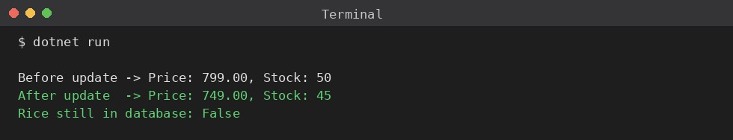
Figure 7: The Wireless Mouse’s price and stock updating in place, followed by the rice product being removed entirely.

Hands-On 7: Writing Queries with LINQ
The final lab moves beyond single-row lookups into LINQ queries that reshape and summarize data — grouping, ordering, and projecting into a shape that isn’t just the raw entity.

Step 1 — Write the Report Queries
using Microsoft.EntityFrameworkCore; using RetailStoreApp.Data;
namespace RetailStoreApp
{
public static class ProductReports
{
public static async Task RunAsync(RetailStoreContext context)
{
var byCategory = await context.Products
.GroupBy(p => p.Category.Name)
.Select(g => new { Category = g.Key, Count = g.Count() })
.ToListAsync();
foreach (var row in byCategory)
{
Console.WriteLine($"{row.Category}: {row.Count} product(s)");
}
var mostExpensive = await context.Products
.OrderByDescending(p => p.Price)
.Select(p => new { p.Name, p.Price })
.FirstAsync();
Console.WriteLine($"Most expensive product: {mostExpensive.Name} ({ mostExpensive.Price:C})");
}
}
}
GroupBy followed by a Select that only pulls out the key and a count is translated into a single GROUP BY query in SQL — the grouping happens on the database, not by loading every row into memory first. The second query chains OrderByDescending with a projection into an anonymous type, so only Name and Price come back over the wire instead of the full Product row.

Step 2 — Call the Report Queries from Program.cs
using RetailStoreApp.Data;
using var context = new RetailStoreContext(); await ProductReports.RunAsync(context);

Step 3 — Run the Application
dotnet run

This closes the loop on the retail inventory system built across all seven labs: plain C# classes (Lab 1), a context that turns them into a database connection (Lab 2), a real schema generated

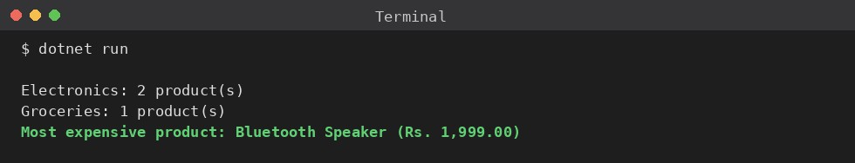
Figure 8: The grouped product counts by category, followed by the most expensive product in the store.

from that model (Lab 3), and full CRUD plus reporting queries running against it (Labs 4 through 7).

